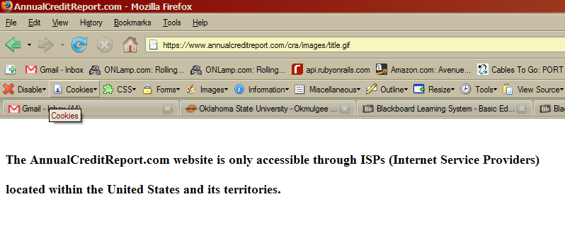
Summary
This error keeps occurring across this website. In fact, this is what their site looks like:
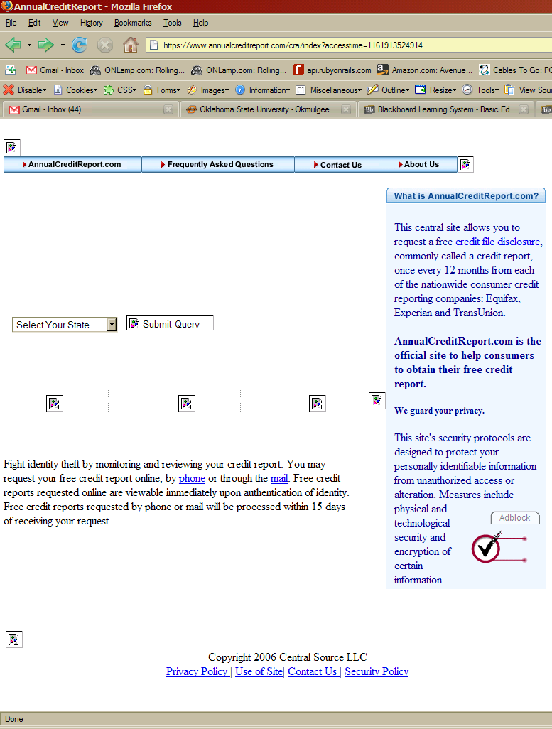
Viewing ANY of the images gets you the above error, and the form won’t complete. I’m going to assume it’s because my IP recently changed and my new hostname at rl-dorms.osu-okmulgee.edu hasn’t changed (so my hostname is 139.78.x.x or whatever). It’s really strange, and is probably related to people who don’t know how to program doing their backend. It happens.

